## **Integer range partitioning**

## **Integer range partitioning**

To create an integer-range partitioned table, it needs

* The partitioning column.
* The starting value for range partitioning (inclusive).
* The ending value for range partitioning (exclusive).
* The interval of each range within the partition.

You have to define the min and max values, and the range size.

**Limitations**

BigQuery has a limit to 4000 partitions per table.

So according to this we can create our own optimized partitioning table.

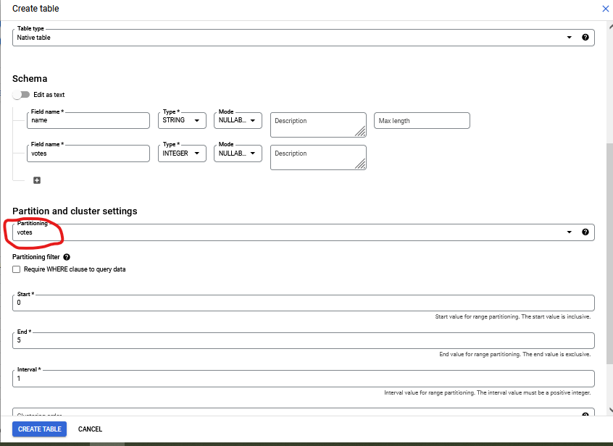

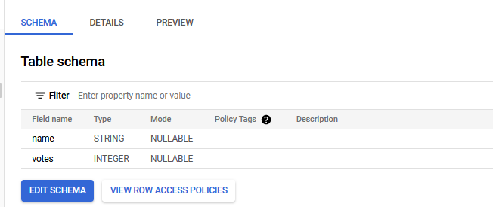

Now, we have up to 5 partitions on this table. Fill it with the right values in the partition fields.

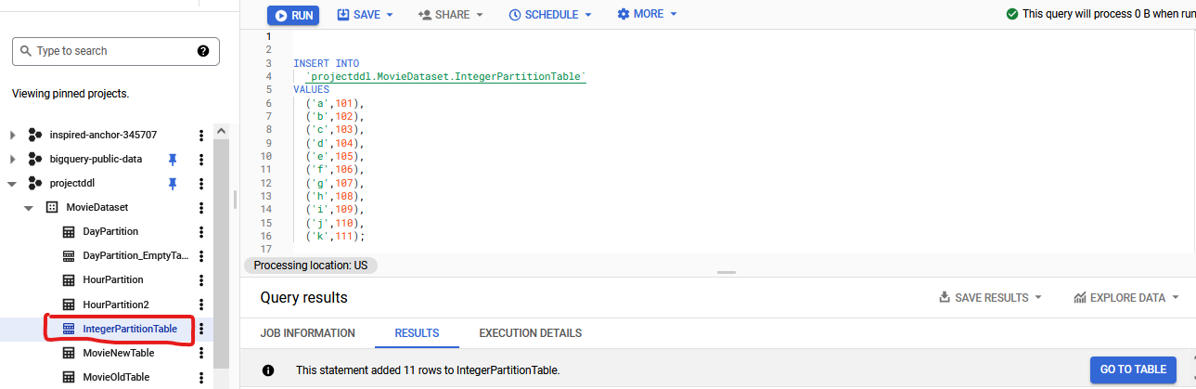

**Table Result**

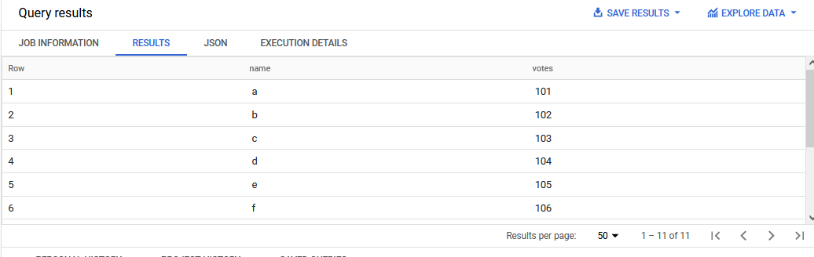

select votes from `projectddl.MovieDataset.IntegerPartitionTable` ;